**Exercise 22: Demo about Optional parameters and Link**

Objectives and Outcomes

This exercise is a demo that showcases how to use optional parameters and the Link component in React using react-router-dom version 6. In this example, we'll create a simple navigation menu with links that can accept optional parameters.

Exercises

* Create Navbar as image below

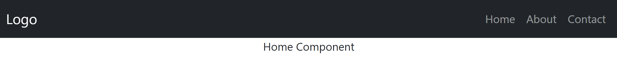

Install:

"react-router-dom": "^6.16.0"

"reactstrap": "^9.2.0"

const Home = () => <div align='center'>Home Component</div>;

const About = () => <div align='center'>About Component</div>;

const Contact = () => <div align='center'>Contact Component</div>;

const Profile = () => <div align='center'>Profile Component</div>;

const CustomNavbar = () => {

return (

<Navbar color="dark" dark expand="md">

<NavbarBrand tag={Link} to="/">Logo</NavbarBrand>

<Nav className="mr-auto" navbar>

<NavItem>

<NavLink tag={Link} to="/" exact>Home</NavLink>

</NavItem>

<NavItem>

<NavLink tag={Link} to="/about">About</NavLink>

</NavItem>

<NavItem>

<NavLink tag={Link} to="/contact">Contact</NavLink>

</NavItem>

</Nav>

</Navbar>

);

};

const App = () => {

return (

<Router>

<CustomNavbar />

<Routes>

<Route path="/" exact element={<Home />} />

<Route path="/about" element={<About />} />

<Route path="/contact" element={<Contact />} />

<Route path="/profile" element={<Profile />} />

</Routes>

</Router>

);

};

Conclusion

This demo demonstrates how to use optional parameters and the Link component in React using react-router-dom version 6.